p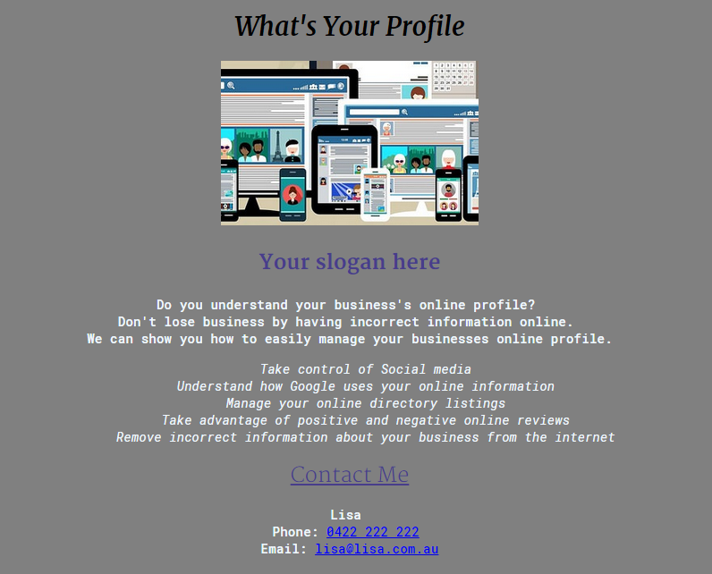

Headline font: Merriweather

This font is very elegant especially in a black text.

Body font: Roboto Mono

This font feels very heavy and I had to play with the weight to get the type to feel like it is delivering the right message.

The lighter weighted Roboto Mono works well with a heavy weighted Merriweather font I didn’t like Roboto Mono initially but I think it works well with the list text.

I don’t think this combination conveys the right message to the target audience. It look confusing whereas my business idea is about unconfusing digital presence.

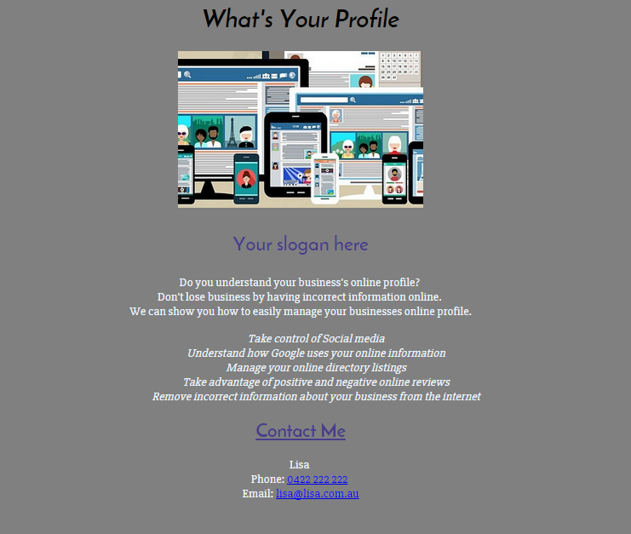

Headlines: Josefin Sans

I like this font as a headline font it feels tall and important

Body Text: Slantbo 27px

The body text is easy to read. I have italicised the list to help differentiate from the first paragraph.

Initially I didn’t think the two fonts would work but they are highly contrasting. The contrast helps give the body text more emphasis and possibly helps it appear more legible.